Case Study: How Does a Bike-Share Navigate Speedy Success?

Introduction

In this case study we will use [data](https://divvy-tripdata.s3.amazonaws.com/index.html) of Cyclistic bike-share provided by the company.

In 2016, Cyclistic launched a successful bike-share offering. Since then, the program has grown to a fleet of 5,824 bicycles that are geotracked and locked into a network of 692 stations across Chicago. The bikes can be unlocked from one station and returned to any other station in the system anytime.

One reason why users are attracted towards this company is that it provides flexibility of its pricing plans: single-ride passes, full-day passes, and annual memberships are Cyclistic members.

Cyclistic’s finance analysts have concluded that annual members are much more profitable than casual riders. Although the pricing flexibility helps Cyclistic attract more customers, Moreno believes that maximizing the number of annual members will be key to future growth. Rather than creating a marketing campaign that targets all-new customers, Moreno believes there is a very good chance to convert casual riders into members. She notes that casual riders are already aware of the Cyclistic program and have chosen Cyclistic for their mobility needs

Scenario

You are a junior data analyst working in the marketing analyst team at Cyclistic, a bike-share company in Chicago. The director of marketing believes the company’s future success depends on maximizing the number of annual memberships. Therefore, your team wants to understand how casual riders and annual members use Cyclistic bikes differently. From these insights, your team will design a new marketing strategy to convert casual riders into annual members. But first, Cyclistic executives must approve your recommendations, so they must be backed up with compelling data insights and professional data visualizations.

Characters

• **Lily :** The director of marketing and your manager. Moreno is responsible for the development of campaigns and initiatives to promote the bike-share program. These may include email, social media, and other channels.

• **Cyclistic marketing analytics team:** A team of data analysts who are responsible for collecting, analyzing, and reporting data that helps guide Cyclistic marketing strategy. You joined this team six months ago and have been busy learning about Cyclistic’s mission and business goals — as well as how you, as a junior data analyst, can help Cyclistic achieve them.

● **Cyclistic executive team:** The notoriously detail-oriented executive team will decide whether to approve the recommended marketing program.

**B**usiness Task

Analyze rider's usage patterns for marketing membership conversion programs.

**Tools:**R for data cleaning, Tableau for data visualization.

**Dataset:** [Cyclistic’s historical trip data from April 2020 to April 2021](https://divvy-tripdata.s3.amazonaws.com/index.html" \t "_blank)

I used R to combine all the data into one sheet, remove unused columns and export it to a CSV file.

For the R-code, refer to [Github](https://github.com/ankitkhedar12/Google-Analytics-Case-Study-1/blob/main/CaseStudy%20RNotebook.Rmd).

Results :

1. Both casual and members usually rides on weekends more than other days.
2. Most of the users travelled in the months of July, august and September.

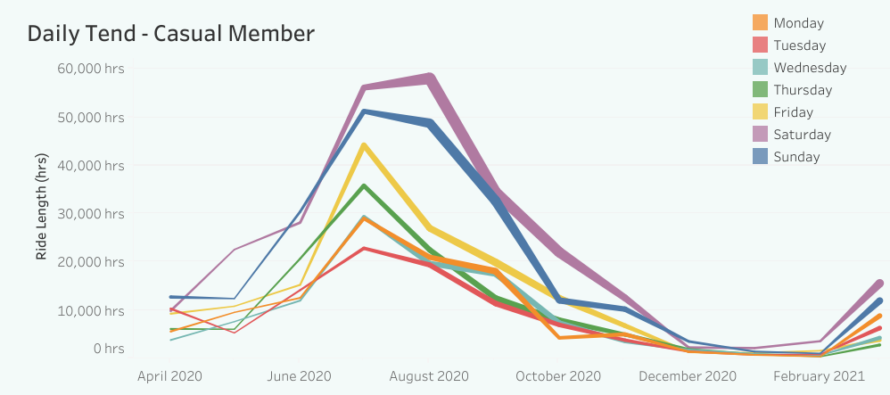

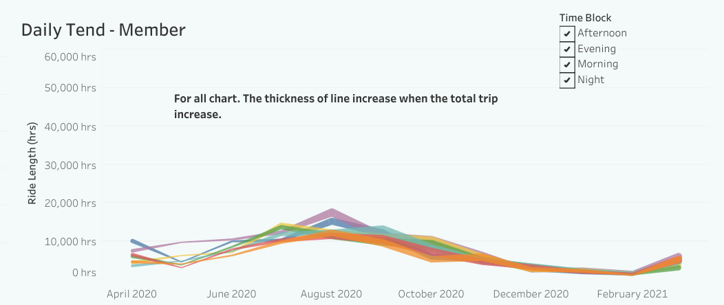

1. Mostly users like to ride Afternoon.

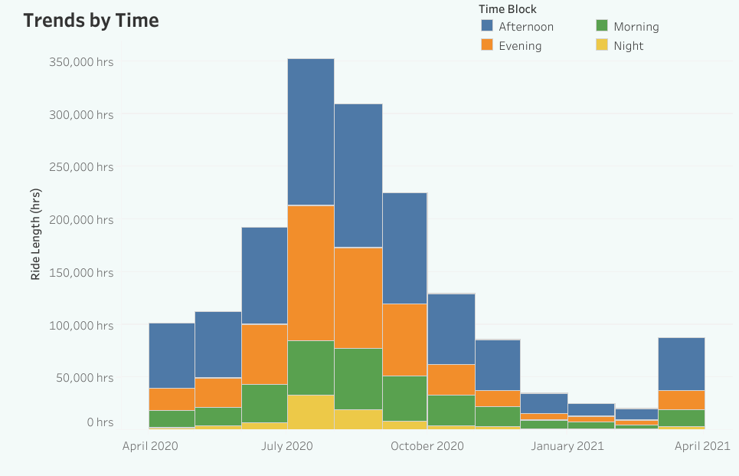

1. Total Trip Duration of Casual Riders is 1.91 times of Member riders.

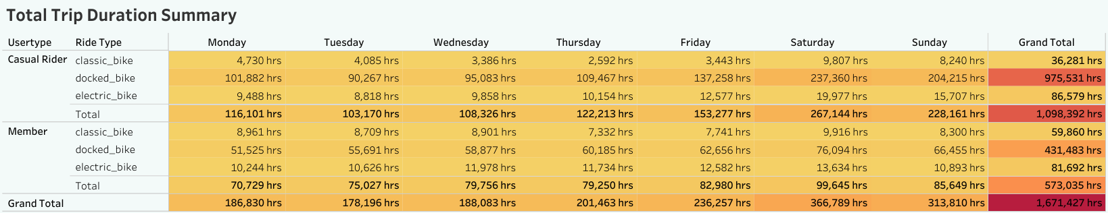

Summary

The total trip duration for casual riders and annual members is affected by season. The temperature is very

low during the winter season, fewer people are willing to go out and people who need to travel daily for

work will choose to take other public transport, this had caused the total trip duration are the lowest among

another season

The annual member display two peak penod which is at 7 a.m and 5 p.m indicate they are most likely office

workers. The casual rider peak period is 4 pm and 5 p.m. The top 20 station visit by casual riders mostly

are tourist locations, the casual riders most likely are a couple, students, retirees, tourists, and family.

Over the years we see a significant divergence of total trip duration from May to September for two groups

of users. This has shown their usage pattern significantly due to their preference and it is more clear when

we look into total trip duration on every single hour within the day. Based on the casual riders monthly total trips durations, the best odds to launch the new marketing campaign is between April to May. Also, consider different price strategies like seasonal passes to increase

the conversion rate. The best would be if the marketing team can run a survey to collect the data from current casual riders understand what kind of features or benefits they look for when considering subscribe annual members